1. Create and configure the app in Azure Active Directory.
2. Create a user in Azure AD and configure it as an application user in Dynamics 365

**Step 1 - Create Azure AD App**

Navigate to Azure (*https://portal.azure.com*).

On the left menu, click on Azure Active Directory -> App registrations (Preview) => + New registration. We will use the Preview version only because it has more straight-forward options and going forward, this only is going to be the default option.

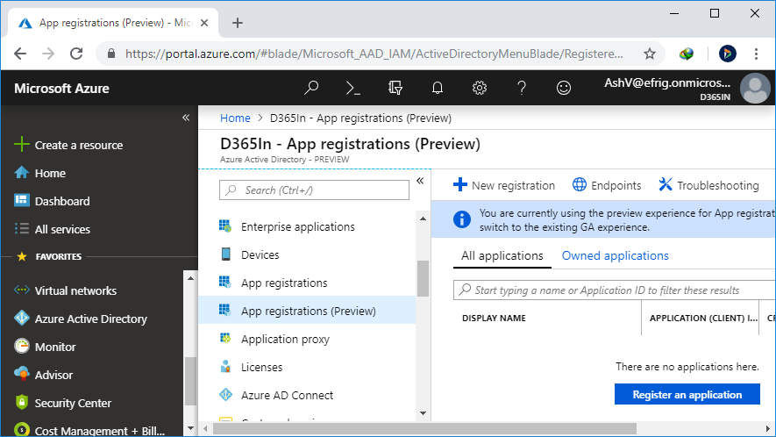

Give some name to your app, and for account type, select "*Accounts in this organizational directory only"* because we need it for a single tenant only.

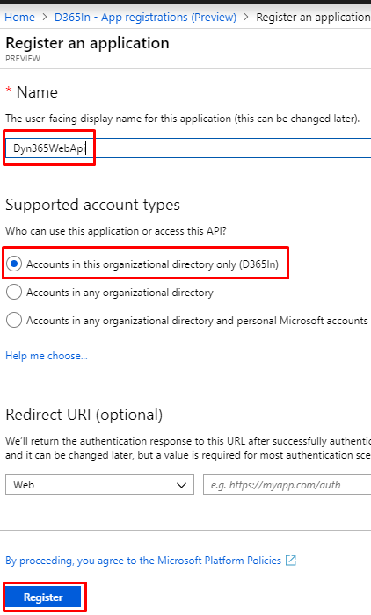

Once the app is created, click on "API permissions" to add a new permission to your app.

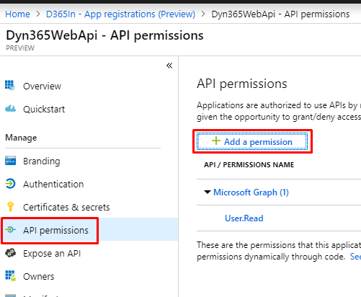

Select Dynamics CRM here.

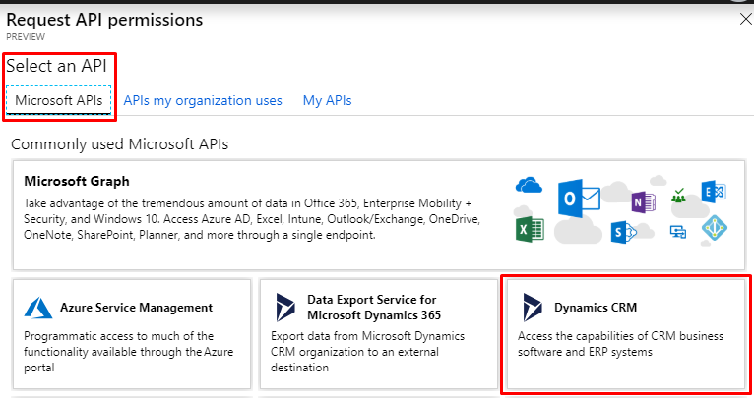

Check the user_impersonation box on the upcoming screen and click "*Add permissions".*

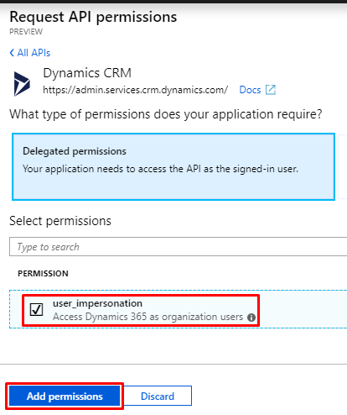

These permissions require admin's consent. Click on the "Grant admin consent for D365In" button and confirm it. You need the administrator role to do it.

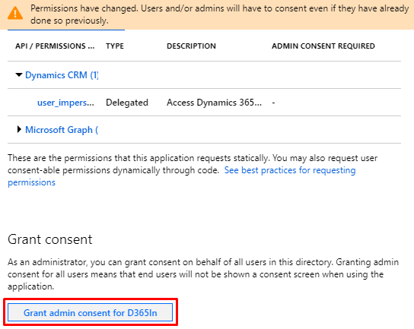

Now, your app is created. We need to use three things:

1. Application Id, aka, Client Id
2. Tenant Id
3. Client Secret

The Application Id and Tenant Id can be grabbed from the "App Overview".

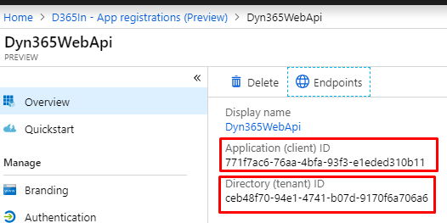

To generate the client secret, go to "Certificates & secrets" and then "+ New client secret". Give some description and select the validity of your secret. Then, click "Add".

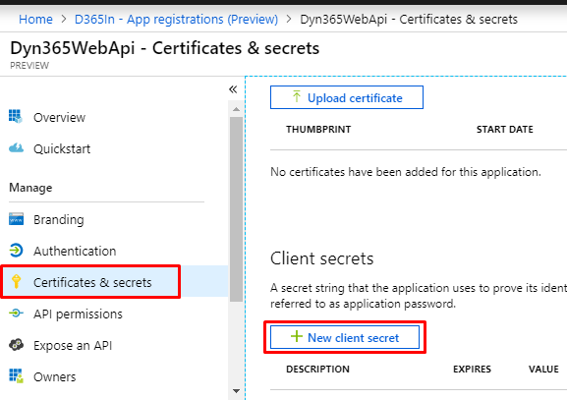

Client Secret is something that you should keep secret; that is why you can see this only once after generation. Copy it and keep it safe to use later.

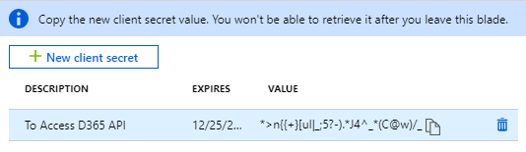

**Step 2: Create Application User**

* You need to create a new user. All CRM API calls will be made on behalf of this user.
* This user does not require a Dynamics 365 license.
* This user should be created from Azure (*https://portal.azure.com*), not from Office Portal (*https://admin.microsoft.com*)
* Navigate to Azure -> Azure Active Directory -> Users and click on "+New user".

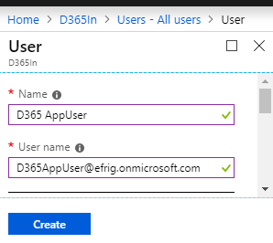

* Here, the username field must have the same domain name as your organization.
* Once this user is created, go to your Dynamics 365 instance.
* Navigate to Dynamics 365 -> Settings -> Security; click on "Users" here.
* Change the view to "Application Users" and click on "+ NEW" to create a new application user.

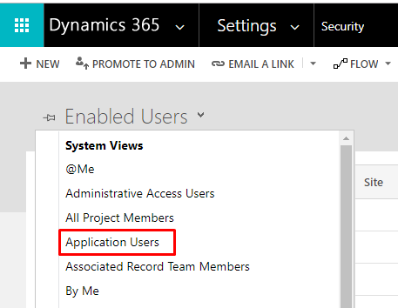

* You may need to set the form also as an Application User if it’s not coming by default.

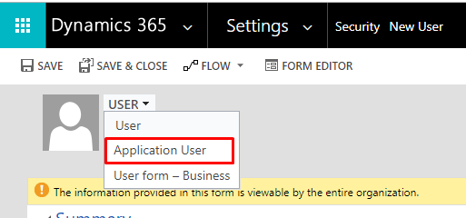

* Here, the Application ID must be the same as Azure AD App created in the previous step.

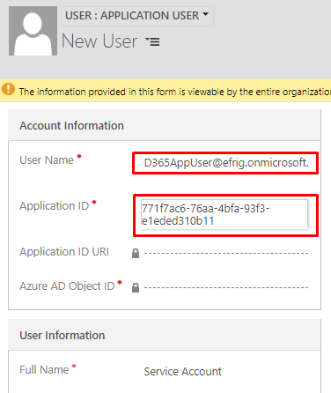

* Now, you need to assign a security role to this user to perform an operation on desired records.